1.5 Number system

000  
001  
002  
003  
004  
005  
006  
007  
008  
009  
010  
012  
013  
014  
015  
016  
017  
018  
019  
020

0,1,2,3,4,5,6,7,8,9 – 10 digits – Decimal number system

000  
001  
010  
011  
100  
101  
110  
111

0,1 – 2 digits – Binary number system (voltage)  
  
How many digits – base  
Base 10: Decimal [0,1,2,3,4,5,6,7,8,9]  
Base 2: Binary [0,1]  
Base 8: Octal [0,1,2,3,4,5,6,7]  
Base 16: Hexadecimal [0,1,2,3,4,5,6,7,8,9,A,B,C,D,E,F]

|  |  |  |  |
| --- | --- | --- | --- |
| **Decimal** | **Binary** | **Octal** | **Hexadecimal** |
| 0 | 0000 | 000 | 0000 |
| 1 | 0001 | 001 | 0001 |
| 2 | 0010 | 002 | 0002 |
| 3 | 0011 | 003 | 0003 |
| 4 | 0100 | 004 | 0004 |
| 5 | 0101 | 005 | 0005 |
| 6 | 0110 | 006 | 0006 |
| 7 | 0111 | 007 | 0007 |
| 8 | 1000 | 010 | 0008 |
| 9 | 1001 | 011 | 0009 |
| 10 | 1010 | 012 | A |
| 11 | 1011 | 013 | B |
| 12 | 1100 | 014 | C |
| 13 | 1101 | 015 | D |
| 14 | 1110 | 016 | E |
| 15 | 1111 | 017 | F |

Decimal to Decimal

273 = 200 + 70 + 3   
= 2x100 + 7x10 + 3x1   
= 2x10^2 + 7x10^1 + 3x10^0   
= 2xbase^2 + 7xbase^1 + 3xbase^0  
For decimal: b = 10

Binary to Decimal

1101 = 1000 + 100 + 1  
= 1xbase^3 + 1xbase^2 + 1xbase^0  
= 1x2^3 + 1x2^2 + 1x2^0  
= 1x8 + 1x4 + 1x1  
= 8 + 4 + 1  
= 13  
For binary: b =2

Decimal to Binary

13   
13 / 2 = 6; remainder = 1(LSB:goes to the right)  
6 / 2 = 3; remainder = 0  
3/2 = 1; remainder = 1  
1/2 = 0; remainder = 1 (MSD:goes to the left)  
Binary: 1101

2-3 Types of Numbers 1-1  
  
- Real number: any point on the number line  
- Positive number (right to the zero)  
- Negative number (left to the zero)  
- Non – negative number (Positive and zero)

🡨-|--|-|--|--|-|-|-|-|-|-|-🡪

-5 -4 -3 -2 -1 0 1 2 3 4 5  
  
- Natural numbers/ counting numbers: {1,2,3, ……}  
- Whole numbers:{0,1,2,3, ….}  
- Integers: {…., -3,-2,-1,0,1,2,3, ….}  
- Rational(মূলদ) and Irrational(অমূলদ) numbers  
- Rational numbers = 7/2 = 3.5  
- Irrational numbers = 3.14259… (Infinity)

Divisor / ভাজক  
Dividend / ভাজ্য  
Quotient / ভাগফল  
Remainder / ভাগশেষ  
  
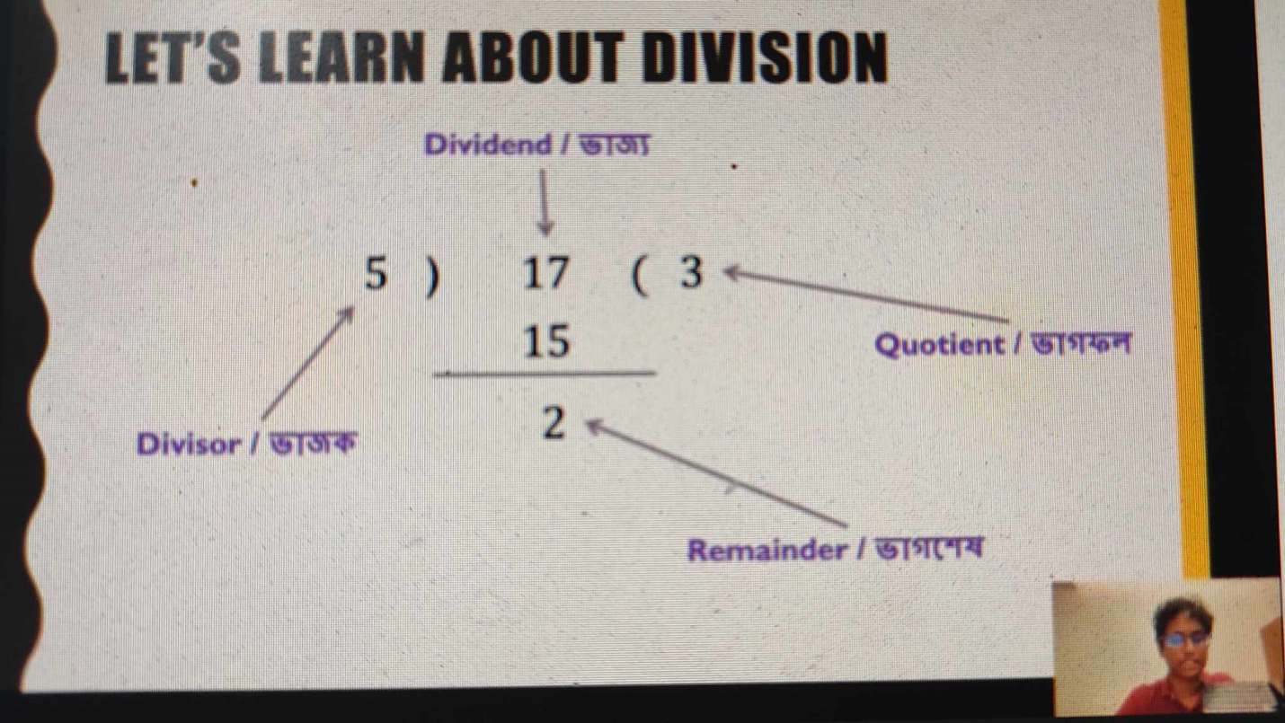

Divisibility Check  
There are two ways:  
- Check if the remainder is zero.  
12 %(mod) 3 = 0 -> 12 is divisible by 5  
12 %(mod) 5 = 2 -> 12 is not divisible by 5  
  
- What do we get if we just do the division?  
12 / 3 = 4 -> Integer 12 is divisible by 3  
12 / 5 = 2.4 -> Not Integer 12 is not divisible by 5

Prime and Composite Numbers  
Think of natural numbers / counting numbers  
- 1,2,3,4,5, …  
Factor: What does it mean when we say

P is a “factor” of Q?

Answer: P divides Q evenly (Remainder is 0). Example: 3 is a factor of 12.

Prime: Only two factors. 1 and itself.  
Composite: There exits at least one factor other than 1 and itself.  
  
What about 1? Is it a prime or composite?

* Special case. Neither!”

2-7 Practice 01  
  
1101011 is a binary number. Find its equivalent decimal number.  
  
1x2^6 + 1x2^5 + 0x2^4 + 1x2^3 + 0x2^2 + 1x2^1 + 1x2^0  
= 2^6 + 2^5 + 2^3 + 2^1 + 2^0  
= 64 + 32 + 8 + 2 + 1  
= 107

Find the binary representation for 73 (a decimal number)

73 / 2 = 36, remainder 1  
36 / 2 = 18, remainder 0  
18 / 2 = 9, remainder 0  
9 / 2 = 4, remainder 1  
4 / 2 = 2, remainder 0  
2 / 2 = 1, remainder 0  
1 / 2 = 0, remainder 1  
Binary: 1001001

Is 77 a prime number? No.

What about 169? Prime or composite?

Composite

Find out the 12th prime number.

2 3 5 7 11 13 17 19 23 29 31 39 37

Find out sum of first n odd number, Try n = 1,2,3

1, 3, 5, 7, 9, 11

1 4 9 16 25 36  
 3 5 7 9 11  
  
**Pattern found = n^2;**

**Floor, Ceiling, Round!**

Floor**:** Nearest integer below  
Ceiling: Nearest integer above  
Round: Nearest integer

2.31 -> floor = 2, ceiling = 3, round = 2  
12.65 -> floor = 12, ceiling = 13, round = 13  
9.21 -> floor = 9, ceiling = 10, round = 9  
24 -> floor = 24, ceiling = 24, round = 24  
  
**Divisor Counting**

Problem statement: Given an integer n. How many divisors are there for n?  
if n is a prime, the answer is 2,   
if n is a composite,(Naïve) (1 to n) test if remainder is 0.  
Better (2 to n-1) test if remainder is 0.  
Efficient (2 to n/2) test if remainder is 0.

**In case of odd, n/2<floor> or n-1/2**

**Divisor Counting – Even Better?**

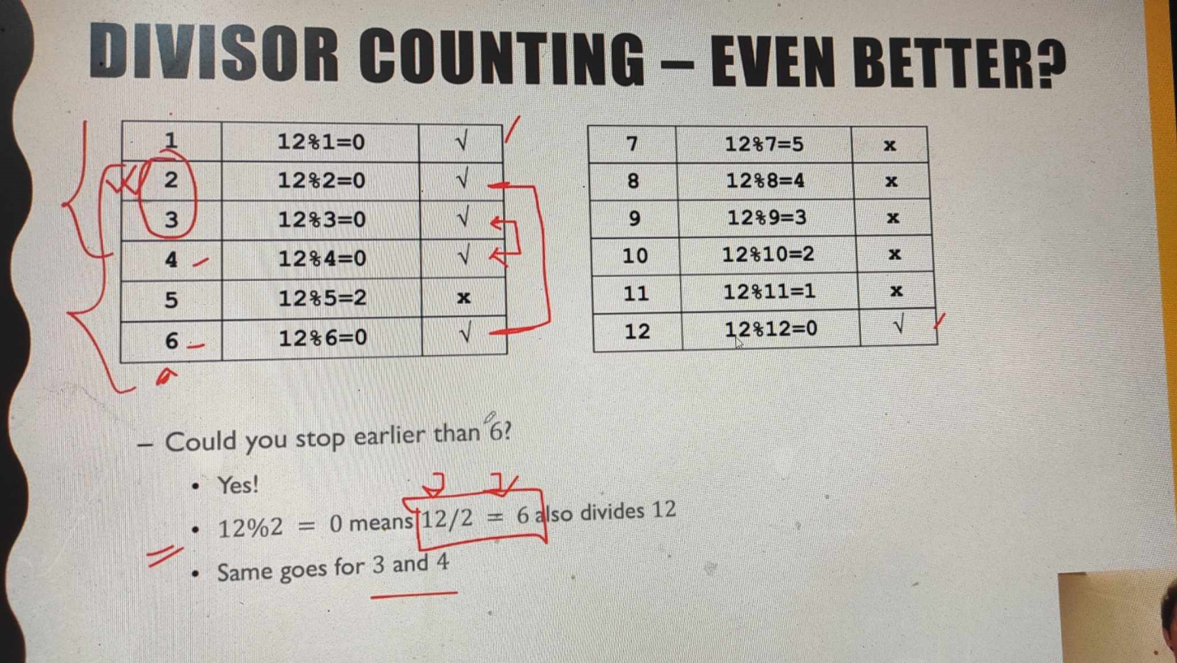

(3-3) 06:35 Count number of Divisors by Going Sqrt(N)-1  
  
Lets take 16  
1x16 = 16  
4x4 = 16  
8x2 = 16 Repeating  
16x 1 = 16 Repeating

**So, we do not need to test any number greater than sqrt(n)**  
sqrt(12) = 3.464(floor = 3), sqrt(16) = 4

**(3-4) Check if a number is prime**

Primality test  
Problem statement: Given an integer n. Determine if n is a prime number or not?  
Is 77 a prime number?  
sqrt(77) = 8.77..  
Check 2 to 8  
 77 % 2 = 1  
 77 % 3 = 2  
 77 % 4 = 1  
 77 % 5 = 2  
 77 % 6 = 5  
 77 % 7 = 0 -> Factors: 7 and 77/7 = 11

Not prime!

But .. do you see the extra calculations we did?

77 % 2 = 1  
 77 % 3 = 2  
 77 % 4 = 1 we know it’s never gonna happen(0)  
 77 % 5 = 2  
 77 % 6 = 5 same  
 77 % 7 = 0 -> Factors: 7 and 77/7 = 11

Can we get a better method?

* Yes, Let’s talk about Sieve of Eratosthenes

SIEVE OF ERATOSTHENES

Identifies all the prime numbers in given range (very fast)  
Idea:  
 Step 1: Take a number (start with 2) and find its multiples in the range  
 Step 2: Those multiples must be composite, cross them out.  
 Step 3: Proceed to next number  
 Step 4: If it’s prime, go to step 1, otherwise step 3

Extract Digits from an integer

Find the i-th digit of a number (Say n = 91408) from right, [i = 0,1,2,3,4]

I = 0 - > n % 10 = 8  
I = 1 - > floor(n/10) % 10 = 0  
I = 2 - > floor(n /100)% 10 = 4  
I = 3 - > floor(n /1000)% 10 = 1  
I = 4 - > floor(n /10000)% 10 = 9

General Formula: Floor(n/10^i ) % 10 = [n/10^i] % 10

From (3-6) Extract Digits from an integer.

GCD – Greatest Common Divisor

গ.সা.গু: গরিষ্ঠ সাধারণ গুণনীয়ক

Divisor  
Common divisor  
Greatest common divisor

Example: Find the gcd of 15 and 6

* Divisors of 15: 1,3,5,15
* Divisors of 6: 1,2,3,6
* Common divisor: 1, 3
* GCD: 3

Co-prime: if gcd(a,b) = 1, a and b are co-prime

* Example: 8 and 15
* Divisors of 15: 1, 3, 5, 15
* Divisors of 8: 1, 2, 4, 8
* Common divisor: 1
* GCD: 1
* That’s why 8 and 15 are co-prime.

Simple way to find gcd(a, b)

* Take i to be 1 to minimum(a, b)

Check if i divides both a and b

Largest such i is the gcd

* Just like the naïve method we learned for finding divisors

Too many unnecessary calculations

Let’s learn a clever way – The Euclidean Algorithm

GCD – The Euclidean Algorithm

gcd(a,b) = gcd(b, a%b)

Example: gcd(p, 0) = gcd(6,3) = gcd(3,0) = gcd(3,0) = 3

Changing order does not matter

* gcd(6,15) = gcd(15,6)

gcd(15, 8) = gcd(8, 7) = gcd(7, 1) = gcd(1, 0) = 1 -> Co-prime

LCM – LEAST COMMON MULTIPLE

ল. সা. গু: লঘিষ্ঠ ‍সাধারণ গুণিতক  
Multiple  
Common multiple  
Least common multiple

Example: Find the lcm of 15 and 6

- Multiples of 15: 15,30,45,60,…  
- Multiples of 6: 6,12,18,24,30,36,42,48,54,60,…  
- Common multiples: 30, 60,…  
- LCM: 30

Simple way to find lcm(a,b)

* Take multiples of the largest number and see if the smaller one divides it
* Computation heavy

Or you may find it using gcd:

* gcd(a,b) x lcm(a,b) = axb [Proof try yourself, Use examples first to understand how it happens]
* দুটো নাম্বারের গ,সাগু ও ল.সা.গু এর গুনফল সেই দুটো নাম্বার এর আসল গুনফল এর সমান
* Example: lcm(15, 6) = (15x6) / 3 = 30

Factorial

A function defined for non-negative integers

* 0, 1, 2, 3,….

n! = nx(n-1)x(n-2)x(n-3)x….x2x1  
4! = 4x3x2x1 = 24  
Exception: 0! = 1

Factorial – Why?

Consider a cricket team with 11 players  
How many batting orders are possible?(11!)  
What if we had 2 players?

* Answer: 2
* AB or BA

What about 3 players?

* Answers: 6
* ABC, ACB, BAC, BCA, CAB, CBA

These types of problems are part of “Combinatorics”

* A branch of mathematics
* Deals with permutation and combination
* More late

Matrix/Matrices

Collection of numbers  
Arranged in rows and columns  
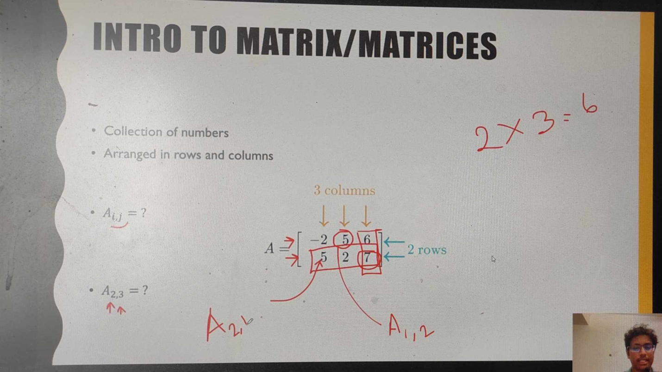

Power and Roots

Power: b^x  
Base and exponent

b^x = b x . . . x b(x times)

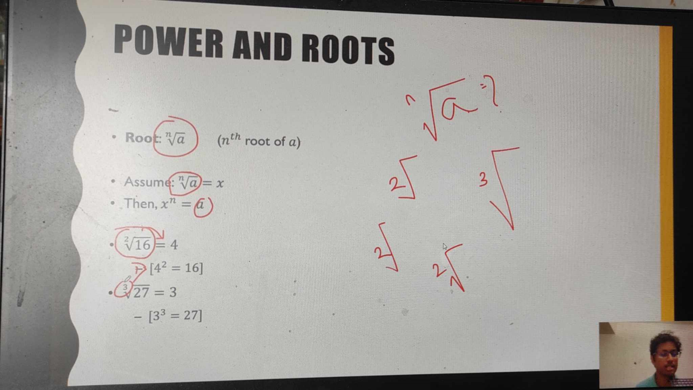5^3 = 5x5x5 = 125

Intro to sets

* No specific order or index [Unlike matrix]

Objects are called elements

Examples

* Natural number set:{1, 2, 3,…}
* Name of your favorite sports: {Cricket, football, hockey, volleyball}

Two kind of sets:

* Infinite set
* Finite set

Subset:

* A is a subset of B if all the elements of A is also in B
* A = {10,12,29} and B = {101,12,10,29,32}

Universal set:

* Depends on context
* Example :

When talking about number, universal set might be the set of Real Numbers

In case of set of favorite sports, universal set would be the set of all sports

Empty/Null set:

* Set with zero members: {} or fai

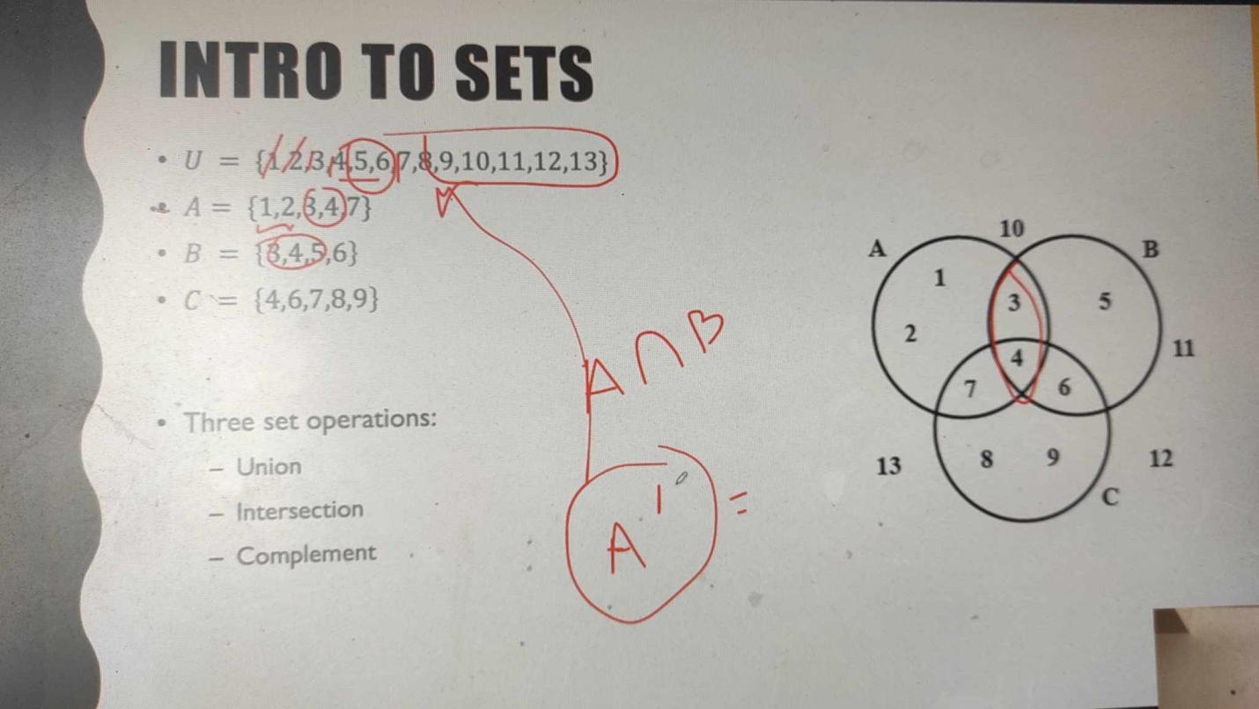

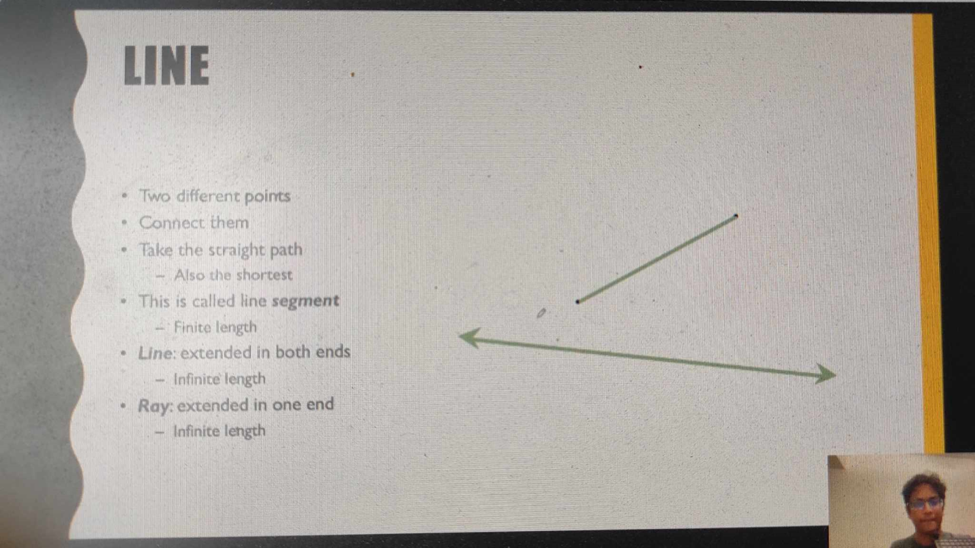

Keywords: Segment, Ray.